Nischal Shrestha
Coventry University Student ID Number: 17103446
B.Sc. (Hons.) Computing, Softwarica College of IT and E-commerce, Coventry University
ST4003CEM Object Oriented Programming
Prabisha Khadka

- Write a program to check whether a person can cast a vote or not. The condition is you must be over 18 years old to vote.

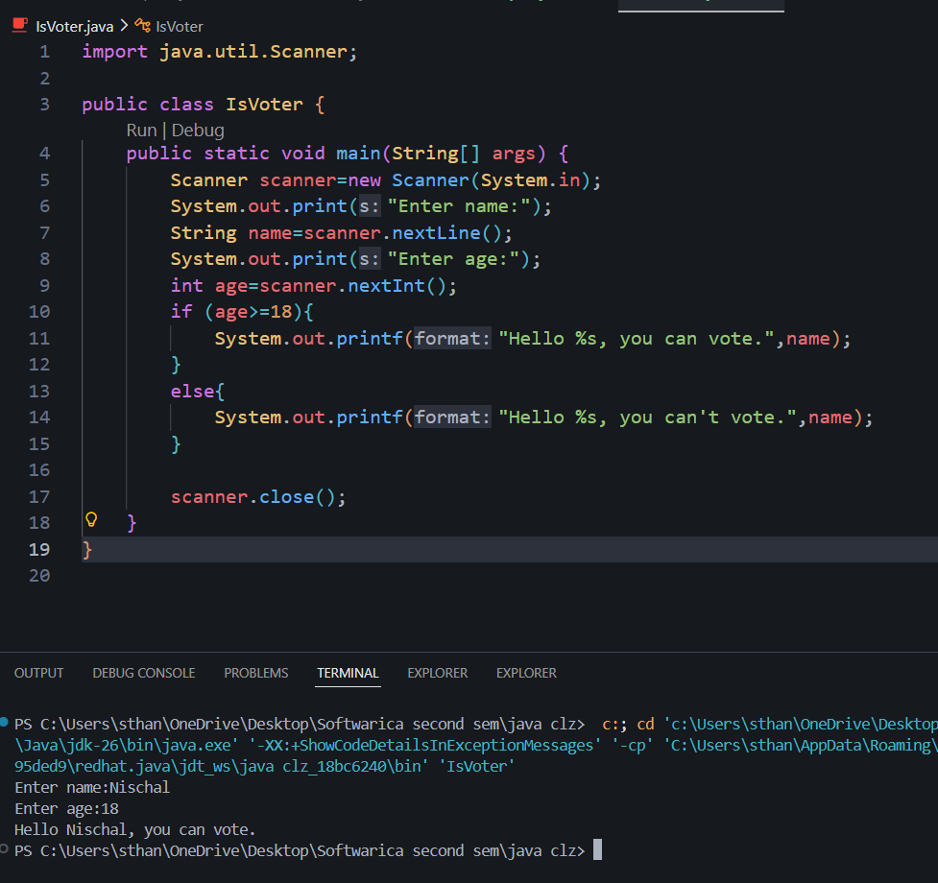

- Write a program to calculate Simple Interest.
Formula Simple Interest = (PrincipleAmount*Time*Rate/100);
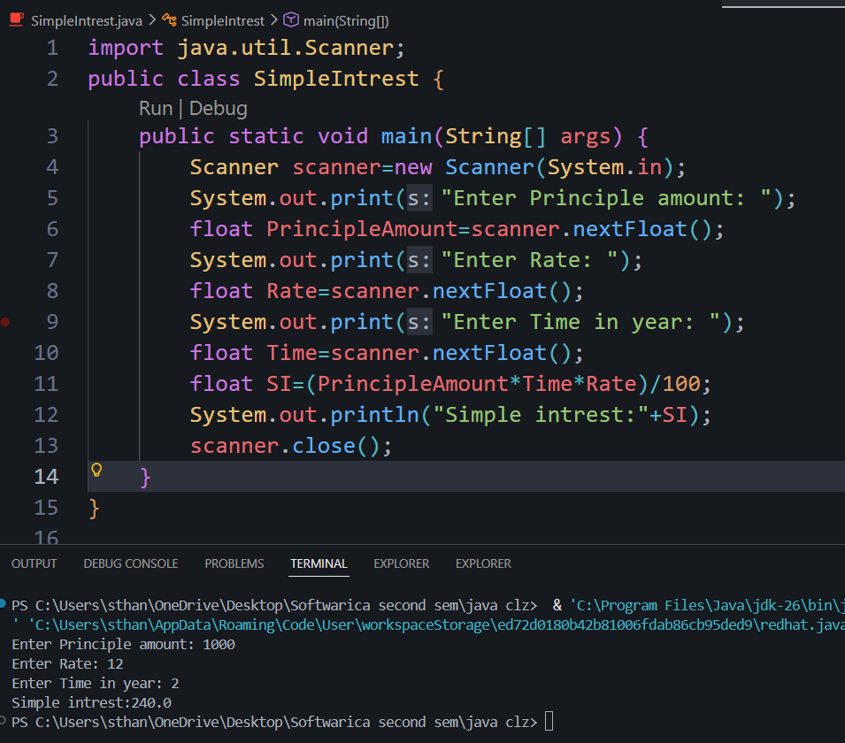

- Write a program to calculate, area of the triangle, and the Volume of the Cube and Cuboid.
Formula: Volume of Cuboid = length*width*height; and Volume of Cube: side*side*side;

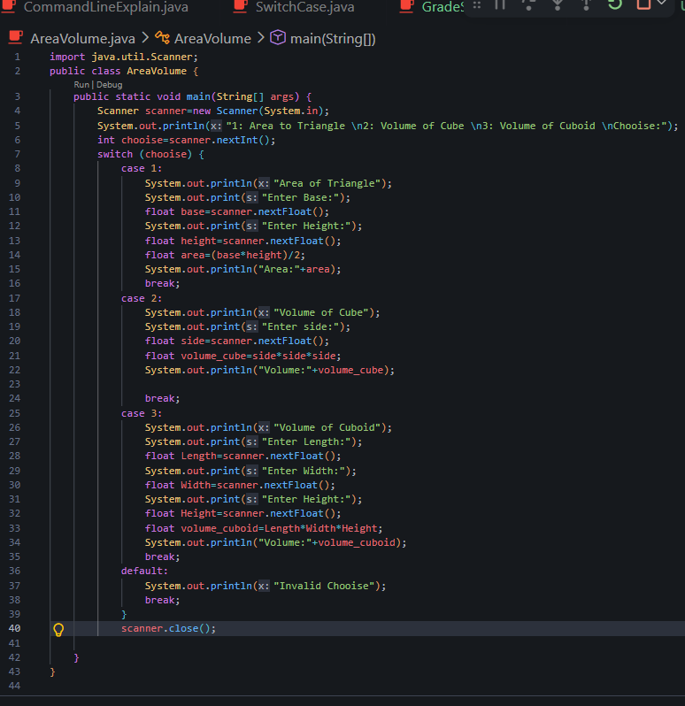

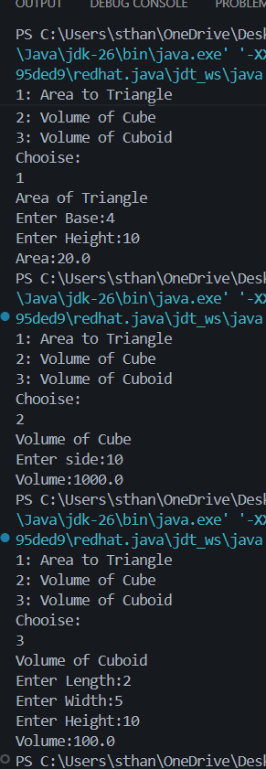
- Write the ternary operator for question no. 1
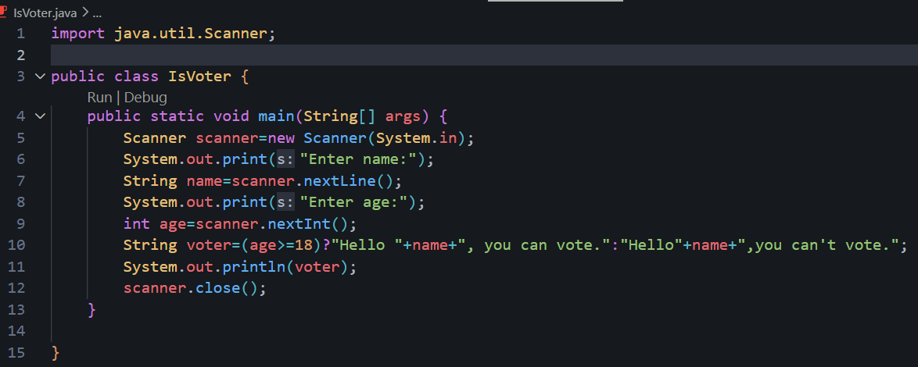

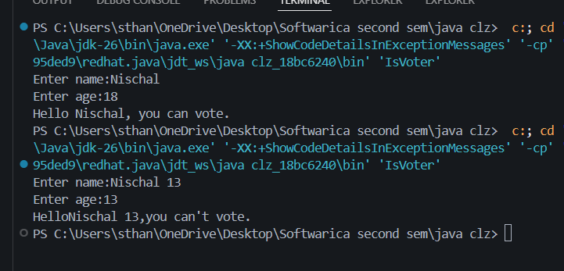

- Write a program to take two integer inputs from the user and print the sum and product of them.
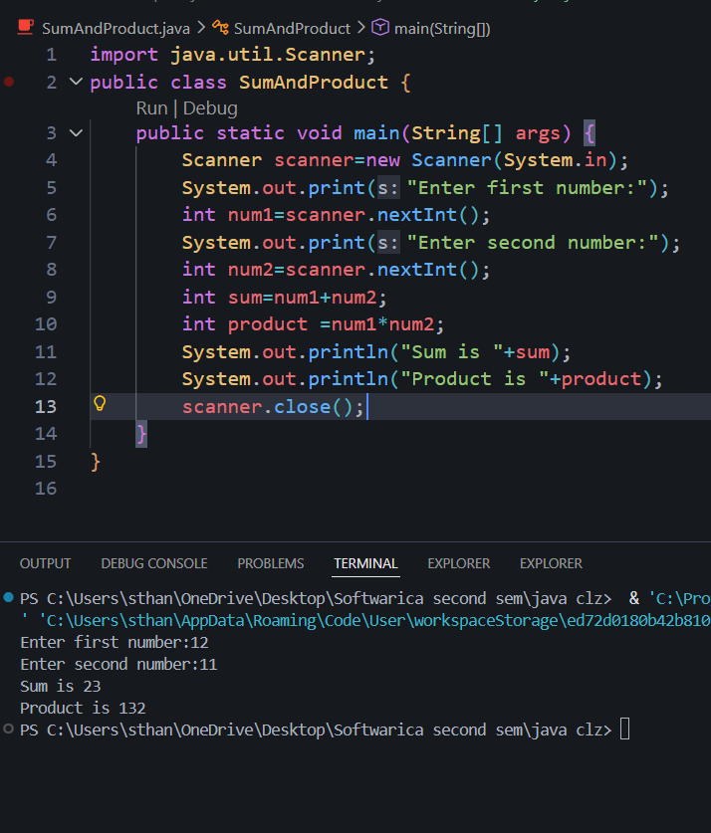

- Take two integer inputs from the user. First, calculate the sum of two, then the product of two. Finally, calculate the division of the thus obtained sum and product and print the result.
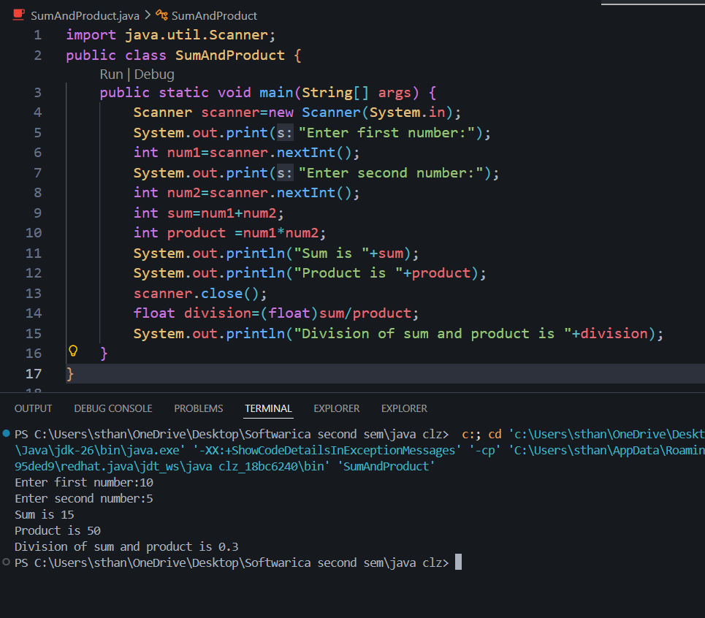

- Take the name, roll number, and field of interest from the user and print in the format below: Hey, my name is XYZ and my roll number is XYZ. My field of interest are xyz.

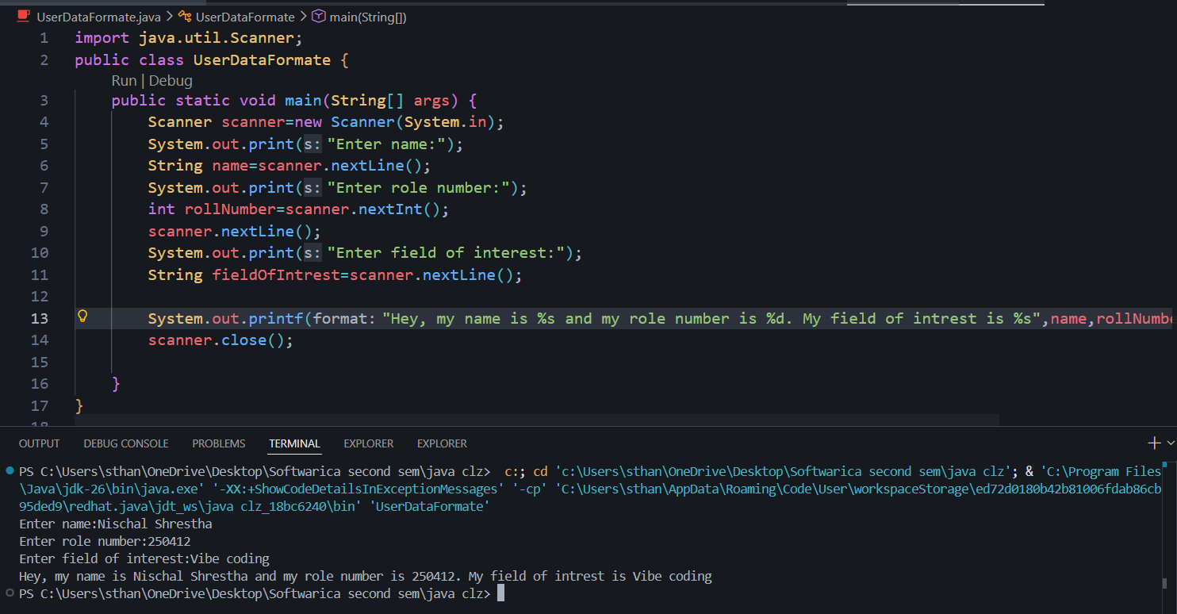

- Take side of a square from user and print area and perimeter of it. Also, calculate Simple Interest, Area of triangle and Volume of Cube and Cuboid. Take the attributes as user input.

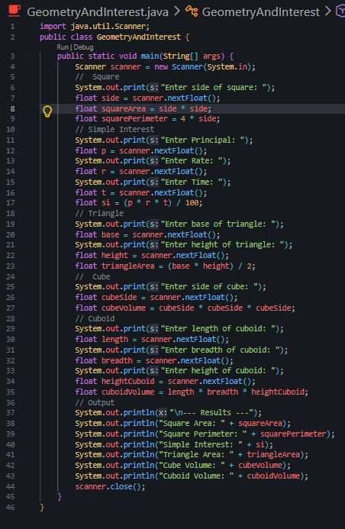

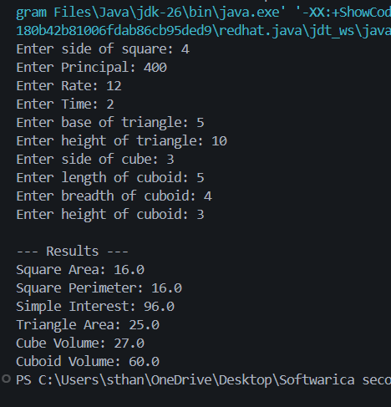

- Ask user to give two double input for length and breadth of a rectangle and print area type casted to int.
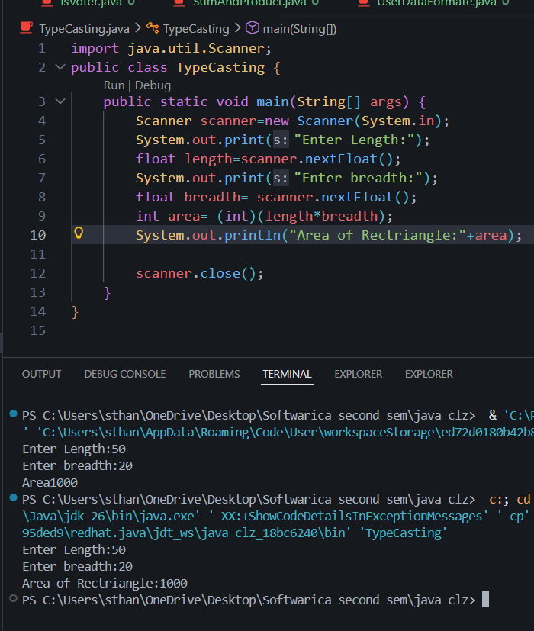

- Write a program to calculate the total marks of four subjects of a student and the total percentage secured. And use the following conditions to generate the final result;
- If equal to or more than 70 -> First Class
- If more than 59 -> Upper Second Class
- If more than 49 -> Second class
- If more than 39 -> Third class and if below than 40 the result is fail.

